# Identify all the different components you know in the following motherboards.

Number 1

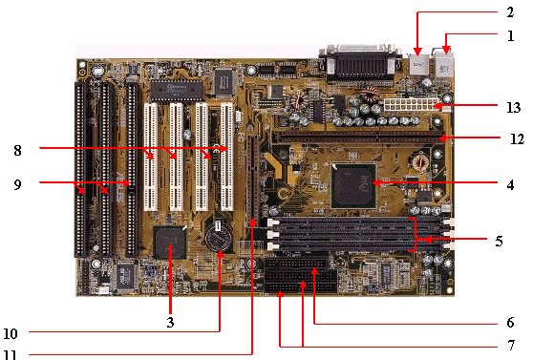

1> Network port

2> USB Port

3> BIOS Chipset

4> CPU Socket

5> RAM Slots

6> Parallel ATA or IDE

7>

8> PCI Slots

9> PCI Express

10> CMOS Battery

11> PCIe x1

12> PCIe x16

13> ATX Power Connector 24-pin

Number 2

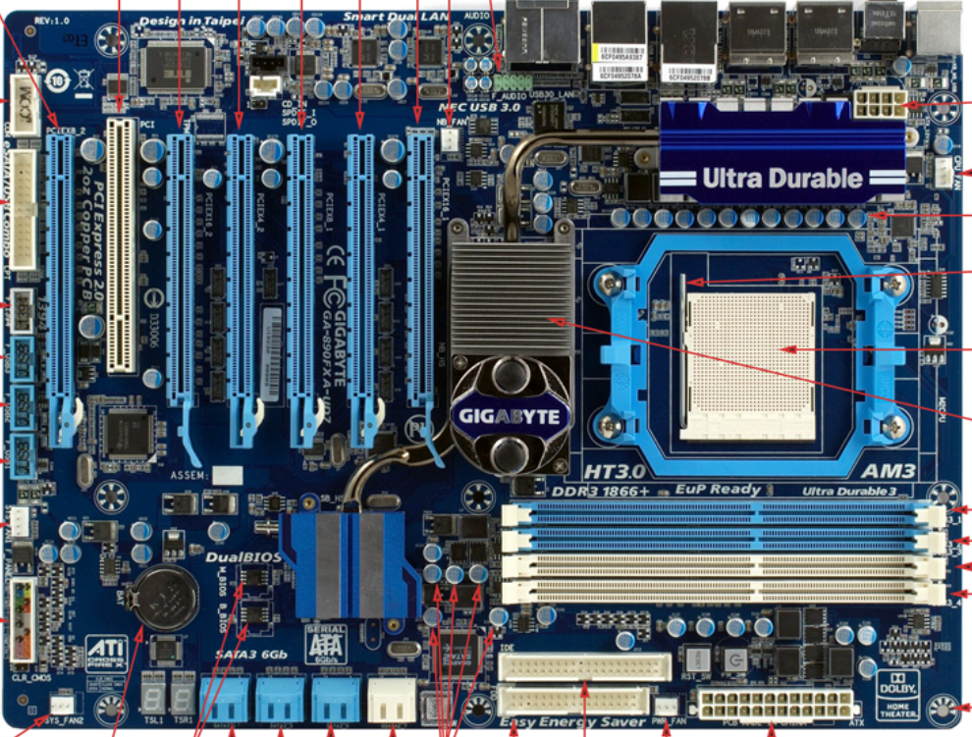

Number 3

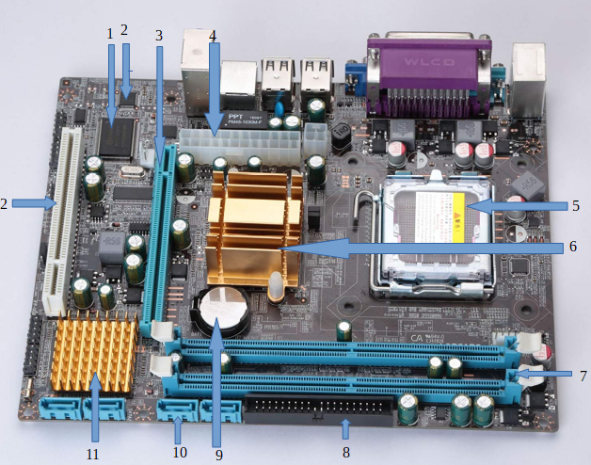

1> BIOS Chipset

2> CMOS Chipset

3> PCI Express

4> ATX Power Connector

5> CPU Socket

6> North Bridge

7> RAM Slots DDR

8> Parallel ATA or IDE

9> CMOS Battery

10> SATA Connectors

11> South Bridge

12> PCI Slot

Number 4

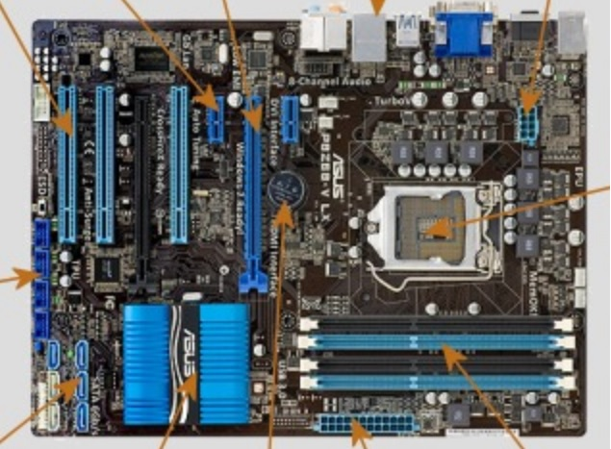

1> PCI Slots

2> PCIe x1

3> PCIe x16 (PCI Express)

4> Rear panel ports

5> ATX 8-pin

6> CPU Socket

7> RAM Slots DDR3 DIMM

8> ATX Power Connector 24-pin

9> CMOS Battery

10> Motherboard Chipset PCH

11> SATA Connectors

12> USB

Number 5

ATX 8-pin

Gaming Heatsinks

CPU Socket

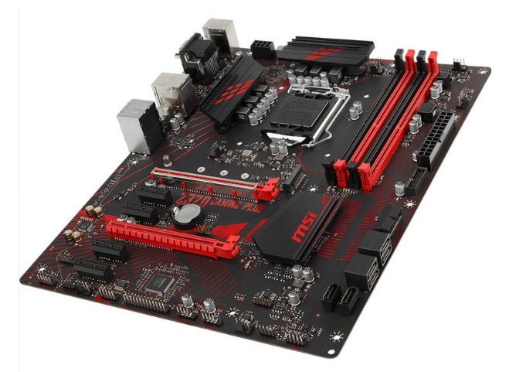

Motherboard Chipset PCH

SATA Connectors

RAM Slots DDR4

ATX Power Connector 24-pin

CMOS Battery

PCIe x1

PCIe x16 (PCI Express)

# Identify the external connectors in the following pictures

Number 1

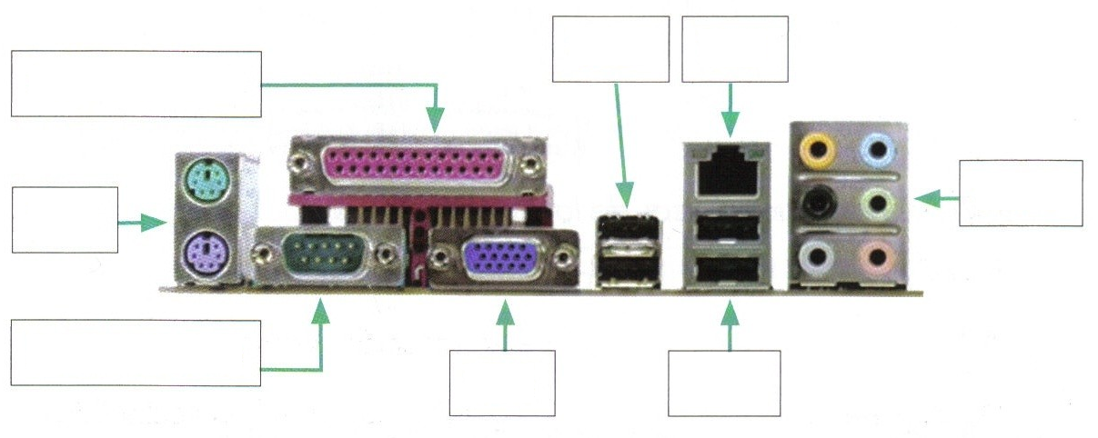

PS/2

Serial

VGA

USB

Audio

RJ-45

USB

Parallel

Number 2

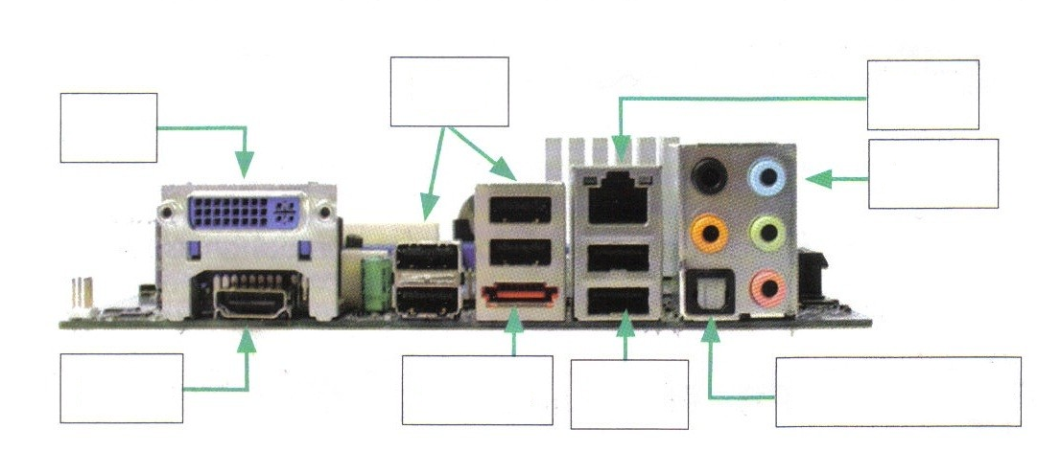

HDMI

e-SATA

USB

S/PDIF

Audio

RJ-45

USB

DVI

Number 3

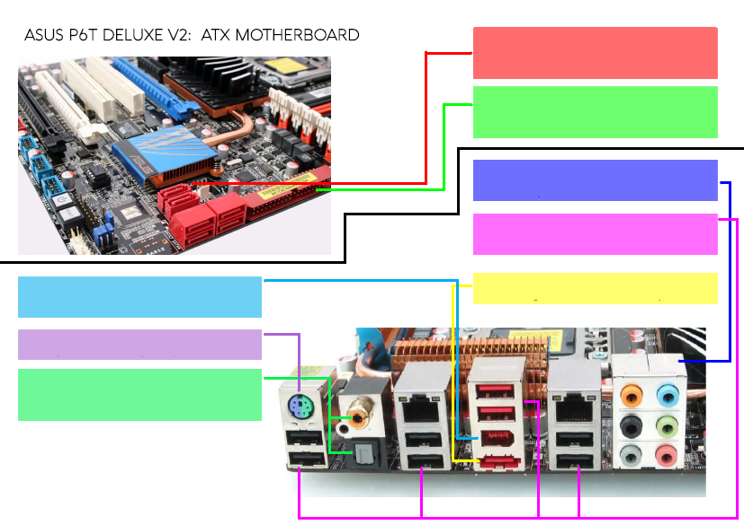

SPDIF OUT

(OPTICAL & COAXIAL)

PS2 PORT

1 IEEE 1394 (FIREWIRE) 6-PIN PORT

1eSATA PORT

8 USB 2.0

635 MM JACKS FOR 7.1 AUDIO

PARALLEL ATA CONNECTORS (IDE)

6 SERIAL-ATA CONNECTORS (SATA3)

Number 4

USB 3.0

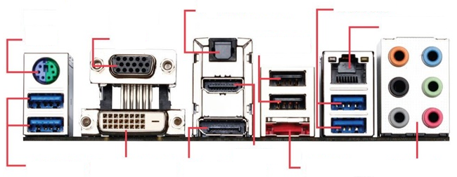

USB 3.0

Dual-link DVI

DISPLAY PORT

HDMI

eSATA

HD AUDIO

ETHERNET

USB 2.0

OPTICAL S/PDIF

VGA

PS/2